**REPORT OF MAJAR PROJECT**





Table of Contents

|  |  |  |
| --- | --- | --- |
| **Sr.no** | **Titles** | **Page No.** |
|  | Abstract |  |
|  | Acknowledgement |  |
| 1. | Project Introduction |  |
| 2. | Need of System |  |
| 3. | Primary Aim |  |
| 4. | Objectives |  |
| 5. | Feasibility Analysis |  |
| 6.  6.1  6.2  6.3 | Risk Analysis  Performance Risks  Safety Risks  Security Risks |  |
| 7.  7.1  7.2  7.3 | Requirement Analysis  User Requirements  Hardware Requirements  Software Requirement |  |
| 8  9. | PHP  MySQl |  |
| 10.  10.1  10.2  10.3 | External Interface  User Interface  Hardware Interface  Communication Interface |  |
| 11. | ER Diagram |  |
| 12. | Data Flow Chart |  |
| 13. | Screenshots |  |
| 14. | Bibliography |  |
| 15. | Coding |  |
| 16. | Conclusion |  |

**Abstract**

This document is a proposal for the “Door to Door café”as the Major Project for the partial fulfillment of the course of Bachelors in Computer Application, Third Year.

This project will teach us the practical implementation of object-oriented programming. Moreover, this will also provide us first-hand experience about several important fields of a Computer Application, like Web Development and Application Development. It will also help us learn programming languages like Webdevelopment scripts like PHP, HTML and CSS and DBMS like MySQL.

Apart from these, we strongly believe going through this project will make us more competent for similar future tasks and enhance our technical and other abilities.

This will help in reduction of paper. As most of the students tend to use towards the electronic media so this idea of our project will make the students to visit the website and keep themselves updated with the college notices.

So basically during this pandemic situation those who are reliable on outdoor food services over website will work as a connection less data transfer system communication so these website will ensure for door to door services.

as per this system, the customer visits the restaurant’s app or website, browses through the various food items, combos and cuisines available there and goes ahead and selects and purchases the items he or she needs .These items will then be delivered to the customer at his or her doorstep at the time they choose by a delivery person.Payments for such online orders can be made through debit cards, credit cards, cash or card on delivery, or even through digital wallets. This system for online food delivery is completely safe, secure and is a very popular method that is revolutionizing the way in which the food industry operates

**1.Project Introduction-**

**The Online Ordering System can be defined as a simple and convenient way for customers to purchase food online, without having to go to the restaurant.This system is enabled by the internet – it is the internet that connects the restaurant or the food company on one hand, and the customer on other hand. Therefore, as per this system, the customer visits the restaurant’s app or website, browses through the various food items, combos and cuisines available there and goes ahead and selects and purchases the items he or she needs .These items will then be delivered to the customer at his or her doorstep at the time they choose by a delivery person.Payments for such online orders can be made through debit cards, credit cards, cash or card on delivery, or even through digital wallets. This system for online food delivery is completely safe, secure and is a very popular method that is revolutionizing the way in which the food industry operates.**

**2.Need of system-**

Almost all leading institutions, excepting a few, currently lack an electronic noticeboard system. Though some have taken the aid of third-party websites like Facebook to interact, it comes at the cost of mixing one’s social life with professional. Keeping this in mind, educational institutes will find this software extremely useful.

The “Digital Notice Board System” is a web- based software, with supplementary application software, that aims to aid the institutes by providing such digital noticeboard

**3.Primary Aim-**

Customers use our platform to search and discover restaurants, read and write customer generated reviews and view and upload photos, order food delivery, book a table and make payments while dining-out at restaurants.

**4**.**Objectives-**

Customers use our platform to search and discover restaurants, read and write customer generated reviews and view and upload photos, order food delivery, book a table and make payments while dining-out at restaurants.

**5.Feasibility Analysis-**

The measure of beneficial or practical the development of informant system will be to anorganisation. long this topic feasibility is measured. far taking the feasibility study and feasibilityanalysis during the development of the protect Online food Ordering system have studied on thefollowing four major categories of feasibility study.

## 6.Risk Analysis-

## 1.Customer Privacy & Data-

**Back in the not-so-olden days, customers simply called up your restaurant to order. Their order was then delivered by a driver employed by the restaurant. Maybe they provided a credit card over the phone. Maybe they paid in cash at the door.  But times have changed. Now customers order on their cellphones and through food delivery apps like Uber Eats and DoorDash**

## 2.Food Safety-

**Food safety should be a concern for every restaurant**, whether they deliver or not. But it becomes especially important for delivery because of the **additional risks**. First and foremost, restaurants should be concerned about maintaining the correct hot and cold holding temperatures of the food they are delivering.

|  |
| --- |
|  |

**6.1Safety Risks**

**6.2Security Risks-**

**The** most common **risks** faced by **delivery** workers, including driving, slips and falls, and thefts. Steps to reduce key exposures such as employee classification and **delivery** exposures, such as auto liability.

**7.Requirement Analysis-**

During the analysis phase, team members will take the derived requirements and transform them into a constant, thorough and complete set of requirements. This will include formulating a use case model, use case descriptions, sequence diagrams, activity diagrams, a UML analysis class diagram and statechart diagrams.

**7.1User Requirements-**

* Create an account.
* Manage their account.
* Log in to the system.
* Navigate the restaurant's menu.
* Select an item from the menu.
* Customize options for a selected item.
* Add an item to their current order.

**7.2 Hardware Requirements**

* A minimum of 2 GB of RAM
* Internet Connection Broadband
* Keyboard and a Microsoft Mouse
* A minimum of 80 GB hard disk

**7.3 Software Requirements**

* Xammp
* MySql
* Html
* Php
* Chrome Browser

**8. PHP**

* PHP is an acronym for "PHP: Hypertext Preprocessor"
* PHP is a widely-used, open source scripting language
* PHP scripts are executed on the server
* PHP files can contain text, HTML, CSS, JavaScript, and PHP code
* PHP code are executed on the server, and the result is returned to the browser as plain HTML
* PHP files have extension ".php"
* PHP can generate dynamic page content
* PHP can create, open, read, write, delete, and close files on the server
* PHP can collect form data
* PHP can send and receive cookies
* PHP can add, delete, modify data in your databas

**9. MySql**

MySQL is a fast, easy-to-use RDBMS being used for many small and big businesses. MySQL is developed, marketed and supported by MySQL AB, which is a Swedish company. MySQL is becoming so popular because of many good reasons −

* MySQL is released under an open-source license. So you have nothing to pay to use it.
* MySQL is a very powerful program in its own right. It handles a large subset of the functionality of the most expensive and powerful database packages.
* MySQL uses a standard form of the well-known SQL data language.
* MySQL works on many operating systems and with many languages including PHP, PERL, C, C++, JAVA, etc.
* MySQL works very quickly and works well even with large data sets.
* MySQL is very friendly to PHP, the most appreciated language for web development.
* MySQL supports large databases, up to 50 million rows or more in a table. The default file size limit for a table is 4GB, but you can increase this (if your operating system can handle it) to a theoretical limit of 8 million terabytes (TB).
* MySQL is customizable. The open-source GPL license allows programmers to modify the MySQL software to fit their own specific environments.

10.External Interface Requirements

10.1User Interfaces

The system will start with a login page to identify the user level and the features will be available accordingly. The application will have easily accessible buttons for all major activities of the software. Key features and recent events will be highlighted to attract user attention.

**10.2Hardware Interfaces**

The system will interact with the hardware resources of the system on which it is running. While any system will support the core software, a device with push messaging facility is recommended for Windows.

**10.3Communications Interfaces**

An active internet connection will be required for the functioning of the software. In case of the mobile apps, an internet connection will then allow the software to connect to the online database. The system will use the Hyper Text Transfer Protocol (HTTP) to transmit data.

**13. Screenshots**

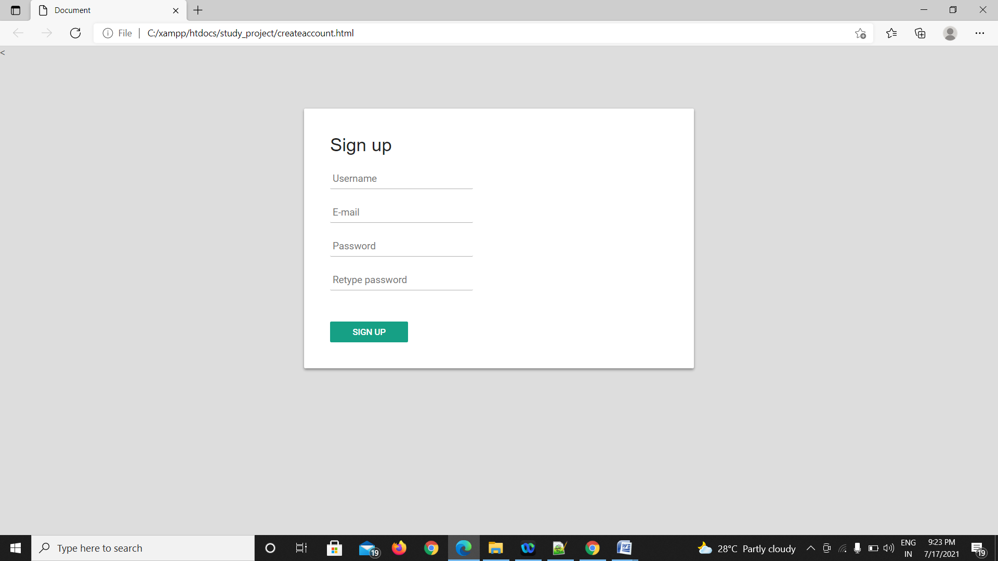

<!DOCTYPE html>

<html lang="en">

<head>

<meta charset="UTF-8">

<meta name="viewport" content="width=device-width, initial-scale=1.0">

<title>Document</title>

<link rel="stylesheet" href="style.css">

<link href="ress.css" rel="stylesheet">

<

</head>

<body>

<form name = "create" method="post" action="create.php">

<div id="login-box">

<div class="left">

<h1>Sign up</h1>

<input type="text" name="username" placeholder="Username" id = "username" />

<input type="text" name="email" placeholder="E-mail" id = "email"/>

<input type="password" name="password" placeholder="Password" id = "password" />

<input type="password" name="password2" placeholder="Retype password" />

<a href="login.html"><input type="submit" name="Submit" id="Submit" value="Sign up"></a>

</div>

</form>

</div>

</body>

</html>

Css

@importurl(https://fonts.googleapis.com/css?family=Roboto:400,300,500);

*:focus {

outline: none;

}

body {

margin: 0;

padding: 0;

background: #DDD;

font-size: 16px;

color: #222;

font-family: 'Roboto', sans-serif;

font-weight: 300;

}

#login-box {

position: relative;

margin: 5% auto;

width: 600px;

height: 400px;

background: #FFF;

border-radius: 2px;

box-shadow: 0 2px 4px rgba(0, 0, 0, 0.4);

}

.left {

position: absolute;

top: 0;

left: 0;

box-sizing: border-box;

padding: 40px;

width: 300px;

height: 400px;

}

h1 {

margin: 0 0 20px 0;

font-weight: 300;

font-size: 28px;

}

input[type="text"],

input[type="password"] {

display: block;

box-sizing: border-box;

margin-bottom: 20px;

padding: 4px;

width: 220px;

height: 32px;

border: none;

border-bottom: 1px solid #AAA;

font-family: 'Roboto', sans-serif;

font-weight: 400;

font-size: 15px;

transition: 0.2s ease;

}

input[type="text"]:focus,

input[type="password"]:focus {

border-bottom: 2px solid #16a085;

color: #16a085;

transition: 0.2s ease;

}

input[type="submit"] {

margin-top: 28px;

width: 120px;

height: 32px;

background: #16a085;

border: none;

border-radius: 2px;

color: #FFF;

font-family: 'Roboto', sans-serif;

font-weight: 500;

text-transform: uppercase;

transition: 0.1s ease;

cursor: pointer;

}

input[type="submit"]:hover,

input[type="submit"]:focus {

opacity: 0.8;

box-shadow: 0 2px 4px rgba(0, 0, 0, 0.4);

transition: 0.1s ease;

}

input[type="submit"]:active {

opacity: 1;

box-shadow: 0 1px 2px rgba(0, 0, 0, 0.4);

transition: 0.1s ease;

}

.or {

position: absolute;

top: 180px;

left: 280px;

width: 40px;

height: 40px;

background: #DDD;

border-radius: 50%;

box-shadow: 0 2px 4px rgba(0, 0, 0, 0.4);

line-height: 40px;

text-align: center;

}

.right {

position: absolute;

top: 0;

right: 0;

box-sizing: border-box;

padding: 40px;

width: 300px;

height: 400px;

background: url('https://goo.gl/YbktSj');

background-size: cover;

background-position: center;

border-radius: 0 2px 2px 0;

}

.right .loginwith {

display: block;

margin-bottom: 40px;

font-size: 28px;

color: #FFF;

text-align: center;

}

button.social-signin {

margin-bottom: 20px;

width: 220px;

height: 36px;

border: none;

border-radius: 2px;

color: #FFF;

font-family: 'Roboto', sans-serif;

font-weight: 500;

transition: 0.2s ease;

cursor: pointer;

}

button.social-signin:hover,

button.social-signin:focus {

box-shadow: 0 2px 4px rgba(0, 0, 0, 0.4);

transition: 0.2s ease;

}

button.social-signin:active {

box-shadow: 0 1px 2px rgba(0, 0, 0, 0.4);

transition: 0.2s ease;

}

button.social-signin.facebook {

background: #32508E;

}

button.social-signin.twitter {

background: #55ACEE;

}

button.social-signin.google {

background: #DD4B39;

}

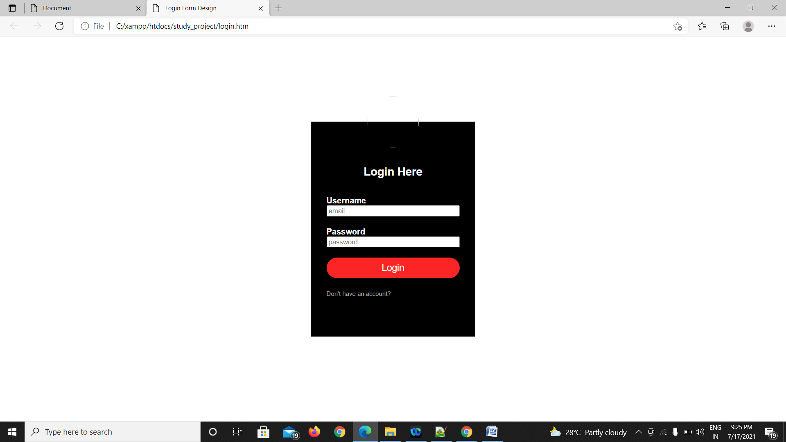

2.login page:



<html>

<head>

<title>Login Form Design</title>

<link rel="stylesheet" type="text/css" href="style5.css">

<body>

<div class="loginbox">

<imgscr="avatar.png" class="avatar">

<h1>Login Here</h1>

<form action="login.php" method="post">

<p>Username</p>

<input type="text" name="email" id="email" placeholder="email">

<p>Password</p>

<input type="password" name="password" id="password" placeholder="password">

<a href="index.html"><input type="submit" name="" value="Login"/></a>

<br>

<a href="index.html" class="btn-full"/>

<a href="createaccount.html">Don't have an account?</a><br>

</form>

</div>

</body>

</head>

</html>

Css

body{

margin: 0;

padding: 0;

background: url(farmer3.jpg);

background-size: cover

background-position: center;

font-family: sans-serif

}

.loginbox{

width: 320px;

height: 420px;

background: #000;

color: #fff;

top: 50%;

left: 50%;

position: absolute;

transform: translate(-50%,-50%);

box-sizing: border-box;

padding: 70px 30px;

}

.avatar{

width: 100px;

height: 100px;

border-radius: 50%;

position: absolute;

top:-50px;

left: calc(50% - 50px);

}

h1{

marging: 0;

padding: 0 0 20px;

text-align: center;

font-size: 22px;

}

.loginbox p{

margin: 0;

padding: 0;

font-weight: bold;

}

.loginbox input{

width: 100%;

margin-bottom: 20px;

}

.loginbox input["type"], inpute[type="password"]

{

border: none;

border-bottom: 1px solid #fff;

background: transparent;

outline: none;

height: 40px;

color: #fff;

font-size: 16px;

}

.loginbox input[type="submit"]

{

border: none;

outline: none;

height: 40px;

background: #fb2525;

color: #fff;

font-size: 18px;

border-radius: 20px;

}

.loginbox input[type="submit"]:hover

{

cursor: pointer;

background: #ffc107;

color: #000;

}

.loginbox a{

text-decoration: none;

font-size: 12px;

line-height: 20px;

color: darkgrey;

}

.loginbox a:hover

{

color: #ffc107;

}

3.index

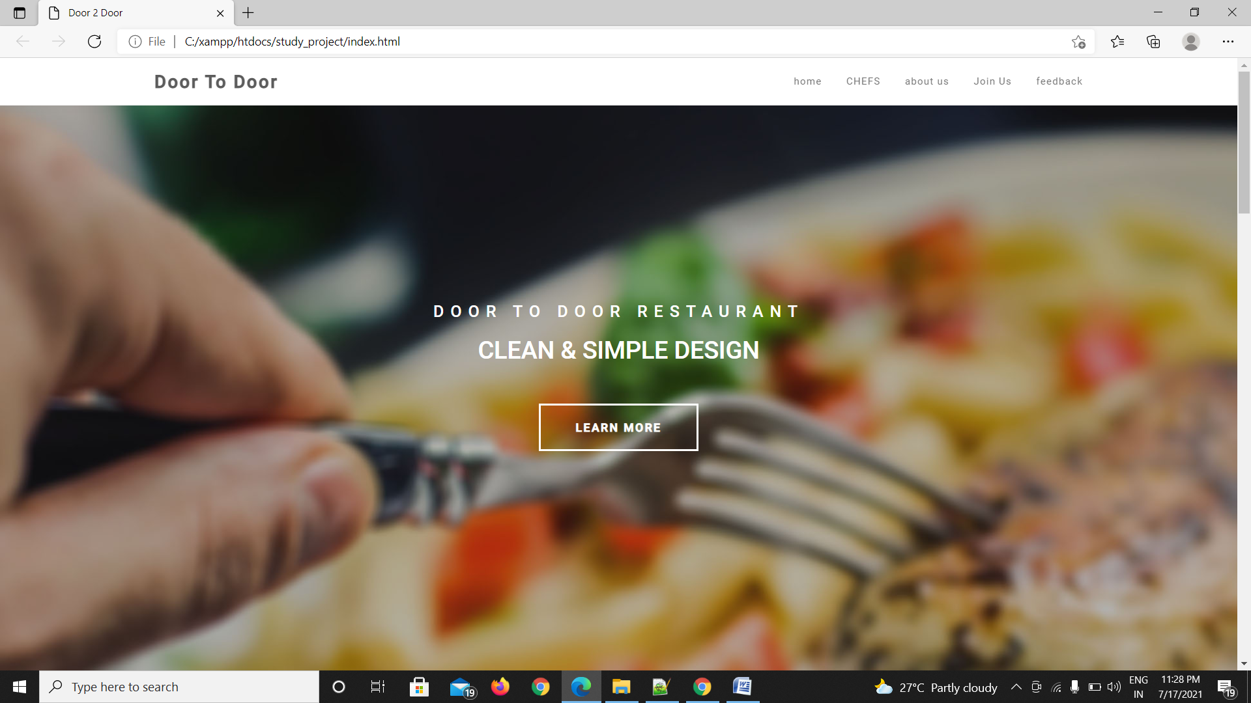

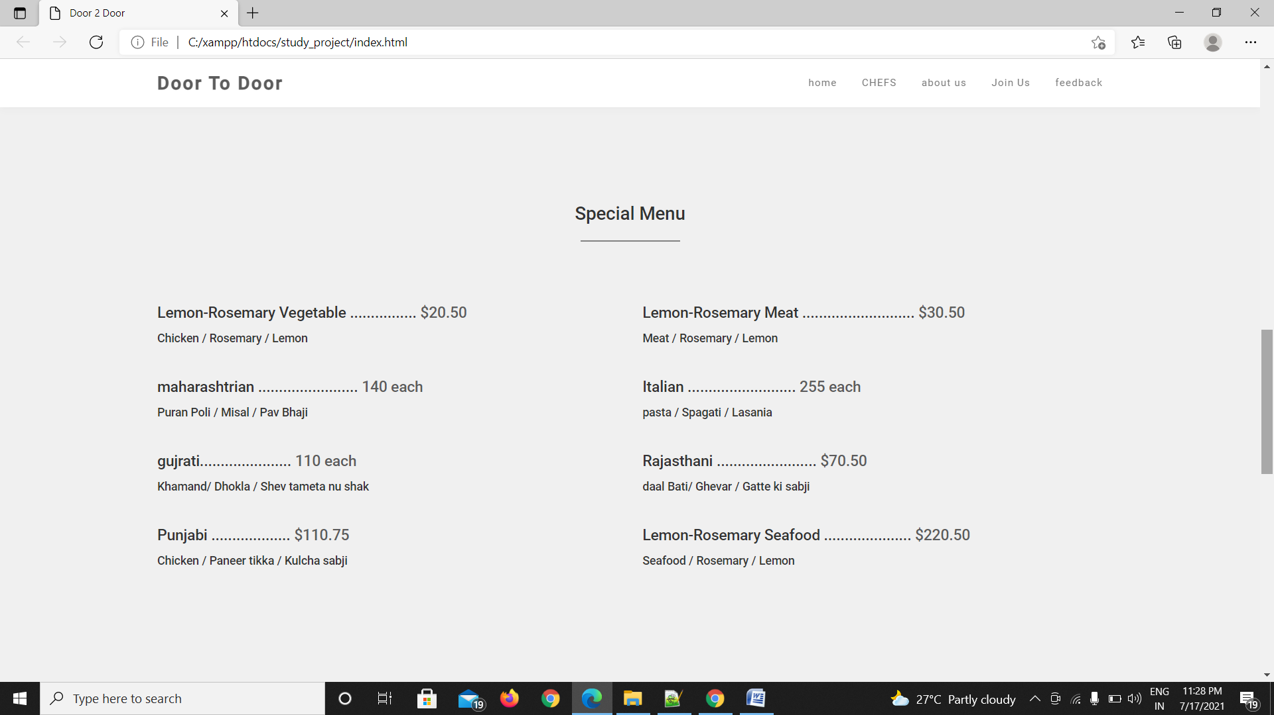

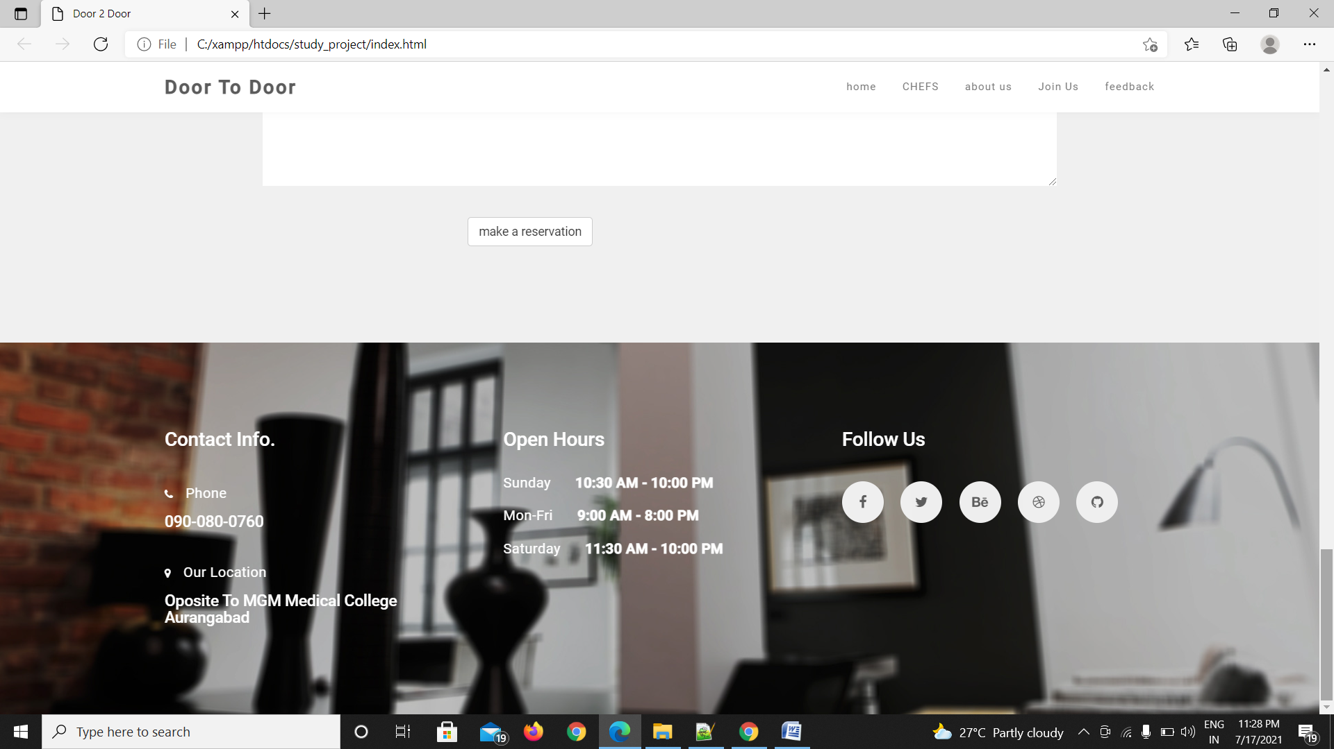

<!DOCTYPE html>

<html lang="en">

<head>

<meta charset="utf-8">

<title>Door 2 Door</title>

<meta http-equiv="X-UA-Compatible" content="IE=Edge">

<meta name="viewport" content="width=device-width, initial-scale=1">

<meta name="keywords" content="">

<meta name="description" content="">

<!--

-->

<link rel="stylesheet" href="css/bootstrap.min.css">

<link rel="stylesheet" href="css/animate.min.css">

<link rel="stylesheet" href="css/font-awesome.min.css">

<link rel="stylesheet" href="css/nivo-lightbox.css">

<link rel="stylesheet" href="css/nivo_themes/default/default.css">

<link rel="stylesheet" href="css/style.css">

<link href='https://fonts.googleapis.com/css?family=Roboto:400,500' rel='stylesheet' type='text/css'>

<style>

.sub-menu-1 {

display: none;

}

.menu-bar ul li:hover .sub-menu-1{

display: block;

position: absolute;

background:transparent;

margin-top: 15px;

margin-left: -15px;

}

.menu-bar ul li:hover .sub-menu-1 ul

{

display: block;

margin: 10px;

}

.menu-bar ul li:hover .sub-menu-1 ul li

{

width: 150px;

padding: 10px;

border-bottom: 1px dotted #fff;

background: white;

border-radius: 0;

text-align: left;

opacity:80%;

}

.menu-bar ul li:hover .sub-menu-1 ul li:last-child

{

border-bottom: none;

}

.menu-bar ul li:hover .sub-menu-1 ul li a:hover

{

color: #b2ff00;

}

</style>

</head>

<body>

<!--preloader section -->

<section class="preloader">

<div class="sk-spinner sk-spinner-pulse"></div>

</section>

<!-- navigation section -->

<section class="navbar navbar-default navbar-fixed-top" role="navigation">

<div class="container">

<div class="navbar-header">

<button class="navbar-toggle" data-toggle="collapse" data-target=".navbar-collapse">

<span class="icon icon-bar"></span>

<span class="icon icon-bar"></span>

<span class="icon icon-bar"></span>

</button>

<a href="#" class="navbar-brand">Door To Door</a>

</div>

<div class="menu-bar">

<ul class="nav navbar-nav navbar-right">

<li><a href="#home" class="smoothScroll">home</a>

<div class="sub-menu-1">

<ul>

<li><a href="indian_dish.html" >Indian</a></li>

<li><a href="chineese_dish.html" >Chinese</a></li>

<li><a href="continental_dish.html" >Continetal</a></li>

</ul>

</div>

</li>

<li><a href="#team" class="smoothScroll">CHEFS</a>

<div class="sub-menu-1">

<ul>

<li><a href="#">Tejas Patil</a></li>

<li><a href="#">Omkar Ganore</a></li>

<li><a href="#">Pawanipatel</a></li>

</ul></div></li></li>

</li>

<li><a href="About Us.html" class="smoothScroll">about us</a>

</li>

</li>

<li><a href="#menu" class="smoothScroll">Join Us</a>

<div class="sub-menu-1">

<ul>

<li><a href="login.htm" >Login</a></li>

<li class="hover-me"><a href="createaccount.html" >Create account</a><i class="fa fa-angle-right"></i>

</li>

</ul>

</div></li></li>

<li><a href="#home" class="smoothScroll">feedback</a>

<div class="sub-menu-1">

<ul>

<li><a href="#"><a href="reating.html" >satisfied</a></li>

<li><a href="#"><a href="reating.html" >not satisfied</a></li>

<li><a href="#"><a href="reating.html" >confused</a></li>

</ul>

</div></li>

</div>

</section>

<!-- home section -->

<section id="home" class="parallax-section">

<div class="container">

<div class="row">

<div class="col-md-12 col-sm-12">

<h1>DOOR TO DOOR RESTAURANT</h1>

<h2>CLEAN &amp; SIMPLE DESIGN</h2>

<a href="About Us.html" class="smoothScrollbtnbtn-default">LEARN MORE</a>

</div>

</div>

</div>

</section>

<!-- gallery section -->

<section id="gallery" class="parallax-section">

<div class="container">

<div class="row">

<div class="col-md-offset-2 col-md-8 col-sm-12 text-center">

<h1 class="heading">Food Gallery</h1>

<hr>

</div>

<div class="col-md-4 col-sm-4 wow fadeInUp" data-wow-delay="0.3s">

<a href="indian_dish.html " data-lightbox-gallery="zenda-gallery"><imgsrc="pure_veg.jpg" alt="gallery img"></a>

<div>

<h3>indian main course</h3>

</div>

<a href="chineese_dish.html" data-lightbox-gallery="zenda-gallery"><imgsrc="chineesedish.jpg" alt="gallery img"></a>

<div>

<h3>chineese_dish</h3>

</div>

</div>

<div class="col-md-4 col-sm-4 wow fadeInUp" data-wow-delay="0.6s">

<a href="continental_dish.html" data-lightbox-gallery="zenda-gallery"><imgsrc="continentaldish.jpg" alt="gallery img"></a>

<div>

<h3>continental_dish</h3>

</div>

</div>

</div>

</div>

</div>

</section>

<!-- menu section -->

<section id="menu" class="parallax-section">

<div class="container">

<div class="row">

<div class="col-md-offset-2 col-md-8 col-sm-12 text-center">

<h1 class="heading">Special Menu</h1>

<hr>

</div>

<div class="col-md-6 col-sm-6">

<h4>Lemon-Rosemary Vegetable ................ <span>$20.50</span></h4>

<h5>Chicken / Rosemary / Lemon</h5>

</div>

<div class="col-md-6 col-sm-6">

<h4>Lemon-Rosemary Meat ........................... <span>$30.50</span></h4>

<h5>Meat / Rosemary / Lemon</h5>

</div>

<div class="col-md-6 col-sm-6">

<h4>maharashtrian ........................ <span>140 each</span></h4>

<h5>PuranPoli / Misal / Pav Bhaji</h5>

</div>

<div class="col-md-6 col-sm-6">

<h4> Italian .......................... <span>255 each</span></h4>

<h5>pasta / Spagati / Lasania</h5>

</div>

<div class="col-md-6 col-sm-6">

<h4>gujrati...................... <span>110 each</span></h4>

<h5>Khamand/ Dhokla / Shev tameta nu shak</h5>

</div>

<div class="col-md-6 col-sm-6">

<h4>Rajasthani ........................ <span>$70.50</span></h4>

<h5>daalBati/ Ghevar / Gatte ki sabji</h5>

</div>

<div class="col-md-6 col-sm-6">

<h4>Punjabi ................... <span>$110.75</span></h4>

<h5>Chicken / Paneer tikka / Kulchasabji</h5>

</div>

<div class="col-md-6 col-sm-6">

<h4>Lemon-Rosemary Seafood ..................... <span>$220.50</span></h4>

<h5>Seafood / Rosemary / Lemon</h5>

</div>

</div>

</div>

</section>

<!-- contact section -->

<section id="contact" class="parallax-section">

<div class="container">

<div class="row">

<div class="col-md-offset-1 col-md-10 col-sm-12 text-center">

<h1 class="heading">table reservation</h1>

<hr>

</div>

<div class="col-md-offset-1 col-md-10 col-sm-12 wow fadeIn" data-wow-delay="0.9s">

<form action="#" method="post">

<div class="col-md-6 col-sm-6">

<input name="name" type="text" class="form-control" id="name" placeholder="Name">

</div>

<div class="col-md-6 col-sm-6">

<input name="email" type="email" class="form-control" id="email" placeholder="Email">

</div>

<div class="col-md-12 col-sm-12">

<textarea name="message" rows="8" class="form-control" id="message" placeholder="Message"></textarea>

</div>

<div class="col-md-offset-3 col-md-6 col-sm-offset-3 col-sm-6">

<h1> <a href="reserved.html" class="smoothScrollbtnbtn-default">make a reservation</a></h1>

</div>

</form>

</div>

<div class="col-md-2 col-sm-1"></div>

</div>

</div>

</section>

<!-- footer section -->

<footer class="parallax-section">

<div class="container">

<div class="row">

<div class="col-md-4 col-sm-4 wow fadeInUp" data-wow-delay="0.6s">

<h2 class="heading">Contact Info.</h2>

<div class="ph">

<p><i class="fa fa-phone"></i> Phone</p>

<h4>090-080-0760</h4>

</div>

<div class="address">

<p><i class="fa fa-map-marker"></i> Our Location</p>

<h4>OpositeTo MGM Medical College Aurangabad </h4>

</div>

</div>

<div class="col-md-4 col-sm-4 wow fadeInUp" data-wow-delay="0.6s">

<h2 class="heading">Open Hours</h2>

<p>Sunday <span>10:30 AM - 10:00 PM</span></p>

<p>Mon-Fri <span>9:00 AM - 8:00 PM</span></p>

<p>Saturday <span>11:30 AM - 10:00 PM</span></p>

</div>

<div class="col-md-4 col-sm-4 wow fadeInUp" data-wow-delay="0.6s">

<h2 class="heading">Follow Us</h2>

<ul class="social-icon">

<li><a href="#" class="fa fa-facebook wow bounceIn" data-wow-delay="0.3s"></a></li>

<li><a href="#" class="fa fa-twitter wow bounceIn" data-wow-delay="0.6s"></a></li>

<li><a href="#" class="fa fa-behance wow bounceIn" data-wow-delay="0.9s"></a></li>

<li><a href="#" class="fa fa-dribbble wow bounceIn" data-wow-delay="0.9s"></a></li>

<li><a href="#" class="fa fa-github wow bounceIn" data-wow-delay="0.9s"></a></li>

</ul>

</div>

</div>

</div>

</footer>

<!-- JAVASCRIPT JS FILES -->

<script src="js/jquery.js"></script>

<script src="js/bootstrap.min.js"></script>

<script src="js/jquery.parallax.js"></script>

<script src="js/smoothscroll.js"></script>

<script src="js/nivo-lightbox.min.js"></script>

<script src="js/wow.min.js"></script>

<script src="js/custom.js"></script>

</body>

</html>

Main maun

**INDIAN_MAIN_COURSE**

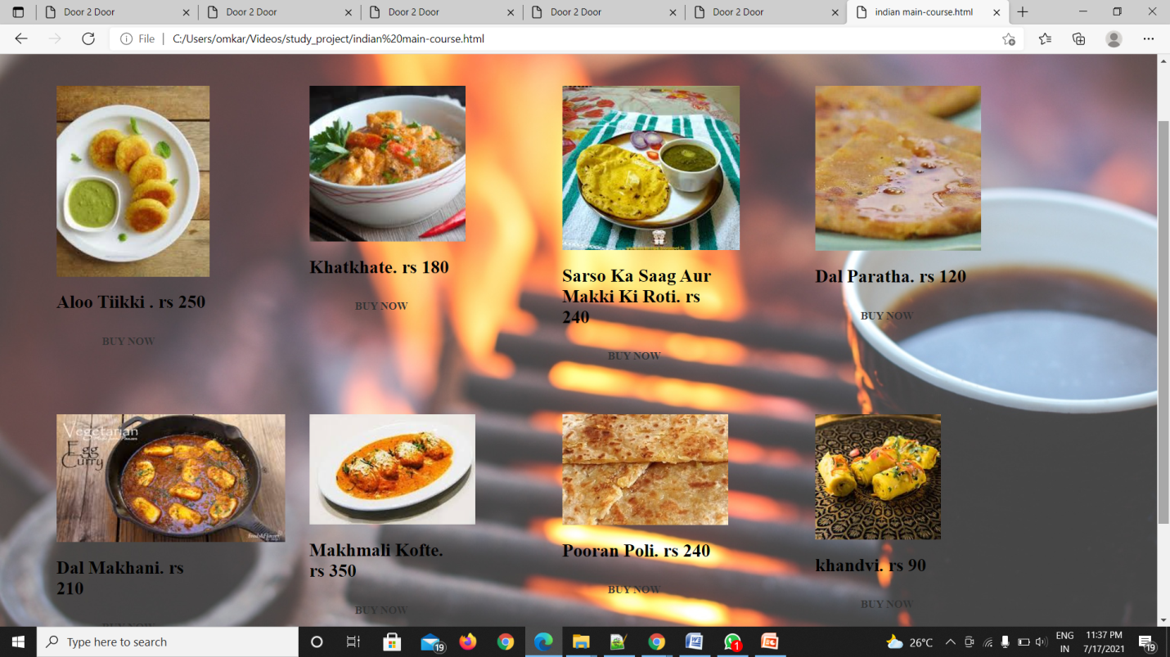

<html>

<head><title>transparant navbar</title></head>

<style>

body{

margin:0;

background:url("food5.JPG");

background-size:cover;

}

.nav{ width:100%;

background:#000033;

height:50px;

margin-top:200px;

opacity:0.7;

}

ul{

list-style:none;

padding:0;

margin:0;

position:relative;

}

li{

float:left;

margin-top:30px;

}

a{

width:550px;

color:white;

display:block;

text-decoration:none;

font-size:20px;

text-align:center;

padding:10px;

border-radius:10px;

font-family:century Gothic;

font-weight:bold;

font-spacing:0.9px;

}

a:hover{

background:#669900;

transition:0.5s;

}

</style>

<body background="food5.JPG">

<div class="nav">

<ul>

<center><a href="indian main-course.html">order</a></center>

</ul>

</body>

</html>

**2. CHINEESE_DISH**

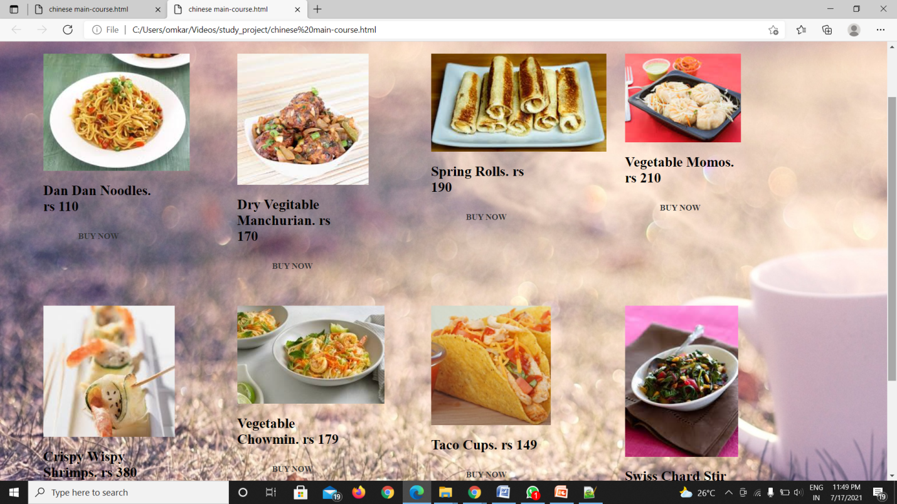

<html>

<BODY STYLE="background-image:url(food11.jpg)">

<head>

<center><h1><b>Main-Course</b></h1></center>

<hr>

</hr>

</head>

<link href="style3.css"rel="stylesheet"type="text/css">

<style>

.content :hover{

color:black;

}

</style>

<div id="main">

<div id="third">

<div id="content">

<imgsrc="veg chowm.JPG"/>

<h2>Dan Dan Noodles. rs 110</h2>

<div class="hero">

<div class="button-awesome">

<a href="payment.html" class="btn-full">BUY NOW</a>

</div>

</div>

</div>

</div>

</div>

<div id="main">

<div id="third">

<div id="content">

<imgsrc="veg manchrian.JPG"/>

<h2>Dry Vegitable Manchurian. rs 170</h2>

<div class="hero">

<div class="button-awesome">

<a href="payment.html" class="btn-full">BUY NOW</a>

</div>

</div>

</div>

</div>

</div>

<div id="main">

<div id="third">

<div id="content">

<imgsrc="zz34.JPG"/>

<h2>Spring Rolls. rs 190</h2>

<div class="hero">

<div class="button-awesome">

<a href="payment.html" class="btn-full">BUY NOW</a>

</div>

</div>

</div>

</div>

</div>

<div id="main">

<div id="third">

<div id="content">

<imgsrc="veg momos.JPG"/>

<h2>Vegetable Momos. rs 210</h2>

<div class="hero">

<div class="button-awesome">

<a href="payment.html" class="btn-full">BUY NOW</a>

</div>

</div>

</div>

</div>

</div>

<div id="main">

<div id="third">

<div id="content">

<imgsrc="crispy.JPG"/>

<h2>Crispy Wispy Shrimps. rs 380</h2>

<div class="hero">

<div class="button-awesome">

<a href="payment.html" class="btn-full">BUY NOW</a>

</div>

</div>

</div>

</div>

</div>

<div id="main">

<div id="third">

<div id="content">

<imgsrc="dan dan.JPG"/>

<h2>Vegetable Chowmin. rs 179</h2>

<div class="hero">

<div class="button-awesome">

<a href="payment.html" class="btn-full">BUY NOW</a>

</div>

</div>

</div>

</div>

</div>

<div id="main">

<div id="third">

<div id="content">

<imgsrc="tacos_2.JPG"/>

<h2>Taco Cups. rs 149</h2>

<div class="hero">

<div class="button-awesome">

<a href="payment.html" class="btn-full">BUY NOW</a>

</div>

</div>

</div>

</div>

</div>

<div id="main">

<div id="third">

<div id="content">

<imgsrc="swiss chard.JPG"/>

<h2>Swiss Chard Stir Fry. rs 130</h2>

<div class="hero">

<div class="button-awesome">

<a href="payment.html" class="btn-full">BUY NOW</a>

</div>

</div>

</div>

</div>

</div>

</body>

</html>

3. CONTINENTAL_DISH

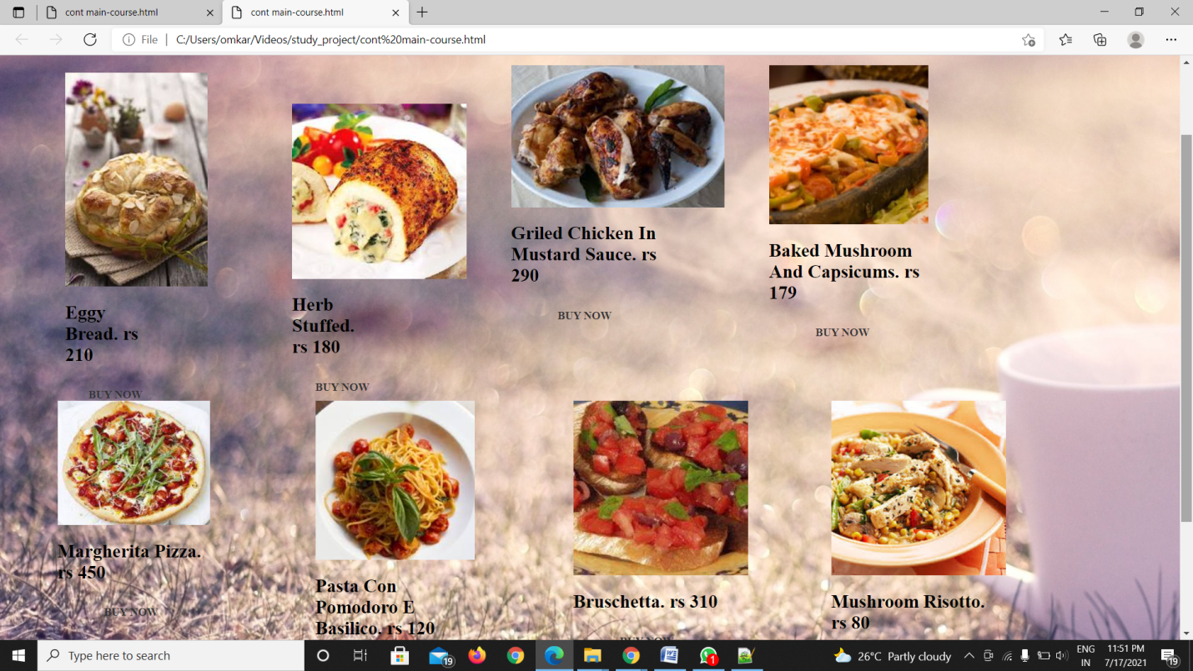

<html>

<BODY STYLE="background-image:url(food11.JPG)">

<head>

<center><h1><b>Main-Course</b></h1></center>

<hr>

</hr>

</head>

<link href="style3.css"rel="stylesheet"type="text/css">

<div id="main">

<div id="first">

<div id="content">

<imgsrc="eggy.JPG"/>

<h2>Eggy Bread. rs 210 </h2>

<div class="hero">

<div class="button-awesome">

<a href="payment.html" class="btn-full">BUY NOW</a>

</div>

</div>

</div>

</div>

</div>

<div id="main">

<div id="second">

<div id="content">

<imgsrc="herb stuffed.JPG"/>

<h2>Herb Stuffed. rs 180 </h2>

<div class="hero">

<div class="button-awesome">

<a href="payment.html" class="btn-full">BUY NOW</a>

</div>

</div>

</div>

</div>

</div>

<div id="main">

<div id="third">

<div id="content">

<imgsrc="grilled.JPG"/>

<h2>Griled Chicken In Mustard Sauce. rs 290</h2>

<div class="hero">

<div class="button-awesome">

<a href="payment.html" class="btn-full">BUY NOW</a>

</div>

</div>

</div>

</div>

</div>

<div id="main">

<div id="third">

<div id="content">

<imgsrc="baked mshroom.JPG"/>

<h2>Baked Mushroom And Capsicums. rs 179</h2>

<div class="hero">

<div class="button-awesome">

<a href="payment.html" class="btn-full">BUY NOW</a>

</div>

</div>

</div>

</div>

</div>

<div id="main">

<div id="third">

<div id="content">

<imgsrc="margrita pizza.JPG"/>

<h2>Margherita Pizza. rs 450</h2>

<div class="hero">

<div class="button-awesome">

<a href="payment.html" class="btn-full">BUY NOW</a>

</div>

</div>

</div>

</div>

</div>

<div id="main">

<div id="third">

<div id="content">

<imgsrc="pasta pomo oro.JPG"/>

<h2>Pasta Con Pomodoro E Basilico. rs 120</h2>

<div class="hero">

<div class="button-awesome">

<a href="payment.html" class="btn-full">BUY NOW</a>

</div>

</div>

</div>

</div>

</div>

<div id="main">

<div id="third">

<div id="content">

<imgsrc="bruschrtts.JPG"/>

<h2>Bruschetta. rs 310</h2>

<div class="hero">

<div class="button-awesome">

<a href="payment.html" class="btn-full">BUY NOW</a>

</div>

</div>

</div>

</div>

</div>

<div id="main">

<div id="third">

<div id="content">

<imgsrc="mashroom riscotta.JPG"/>

<h2>Mushroom Risotto. rs 80</h2>

<div class="hero">

<div class="button-awesome">

<a href="payment.html" class="btn-full">BUY NOW</a>

</div>

</div>

</div>

</div>

</div>

</body>

</html>

2.ABOUT US

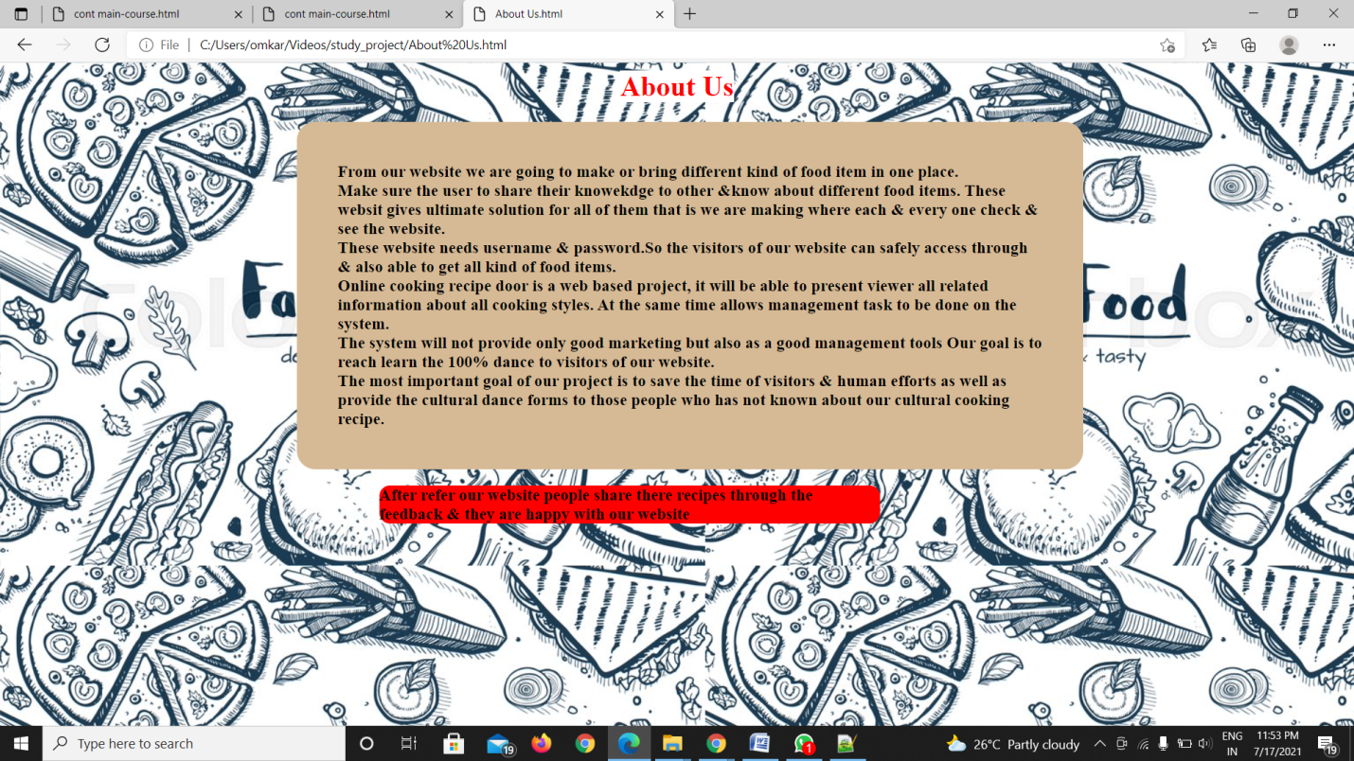

<html>

<head><center><h1><b style="background-color: white; color:red">About Us</center></b></h1></head>

<style>

.boby{

background-color:grey;

}

.deco{

width: 800px;

margin-left: 329px;

background-color: rgb(214, 186, 149);

border: 1px red;

border-radius: 21px;

box-shadow: 2px ;

padding: 46px;

}

</style>

<BODY style="background-image:url(fast_food.jpg);">

<h3><p class="deco">

From our website we are going to make or bring different kind of food item in one place.<br>

Make sure the user to share their knowekdge to other &know about different food items.

These websit gives ultimate solution for all of them that is we are making where each & every one check

& see the website.<br>

These website needs username &password.So the visitors of our website can safely access through & also

able to get all kind of food items.<br>

Online cooking recipe door is a web based project, it will be able to present viewer all related information about all cooking styles.

At the same time allows management task to be done on the system.<br>

The system will not provide only good marketing but also as a good management tools

Our goal is to reach learn the 100% dance to visitors of our website. <br>

The most important goal of our project is to save the time of visitors & human efforts as well as provide

the cultural dance forms to those people who has not known about our cultural cooking recipe.<br>

</p></h3>

<h3><p style="background-color: red;width: 568px;border: 5px; margin-left:422px;border-radius: 12px ;">

After refer our website people share there recipes through the feedback & they are happy with our website

</p></h3>

</body>

</html>

3.join us





4.FEEDBACK

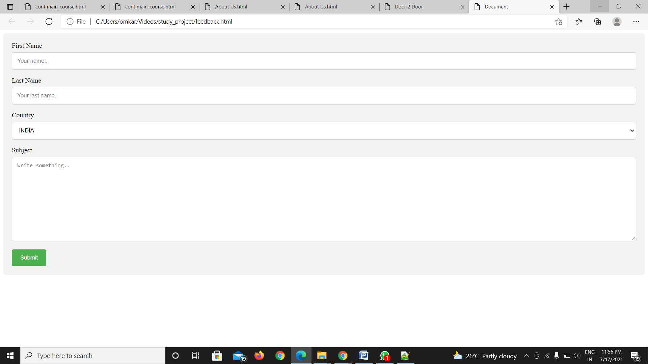

<!DOCTYPE html>

<html lang="en">

<head>

<meta charset="UTF-8">

<meta name="viewport" content="width=device-width, initial-scale=1.0">

<title>Document</title>

<link href="feedback.css" rel="stylesheet">

</head>

<body>

<div class="container">

<form action="feedbackth.html" method="get">

<label for="fname">First Name</label>

<input type="text" id="fname" name="firstname" placeholder="Your name..">

<label for="lname">Last Name</label>

<input type="text" id="lname" name="lastname" placeholder="Your last name..">

<label for="country">Country</label>

<select id="country" name="country">

<option value="australia">INDIA</option>

<option value="canada">Canada</option>

<option value="usa">USA</option>

</select>

<label for="subject">Subject</label>

<textarea id="subject" name="subject" placeholder="Write something.." style="height:200px"></textarea>

<input type="submit" value="Submit">

</form>

</div>

</body>

</html>

Css

/* Style inputs with type="text", select elements and textareas */

input[type=text], select, textarea {

width: 100%; /* Full width */

padding: 12px; /* Some padding */

border: 1px solid #ccc; /* Gray border */

border-radius: 4px; /* Rounded borders */

box-sizing: border-box; /* Make sure that padding and width stays in place */

margin-top: 6px; /* Add a top margin */

margin-bottom: 16px; /* Bottom margin */

resize: vertical /* Allow the user to vertically resize the textarea (not horizontally) */

}

/* Style the submit button with a specific background color etc */

input[type=submit] {

background-color: #4CAF50;

color: white;

padding: 12px 20px;

border: none;

border-radius: 4px;

cursor: pointer;

}

/* When moving the mouse over the submit button, add a darker green color */

input[type=submit]:hover {

background-color: #45a049;

}

/* Add a background color and some padding around the form */

.container {

border-radius: 5px;

background-color: #f2f2f2;

padding: 20px;

}

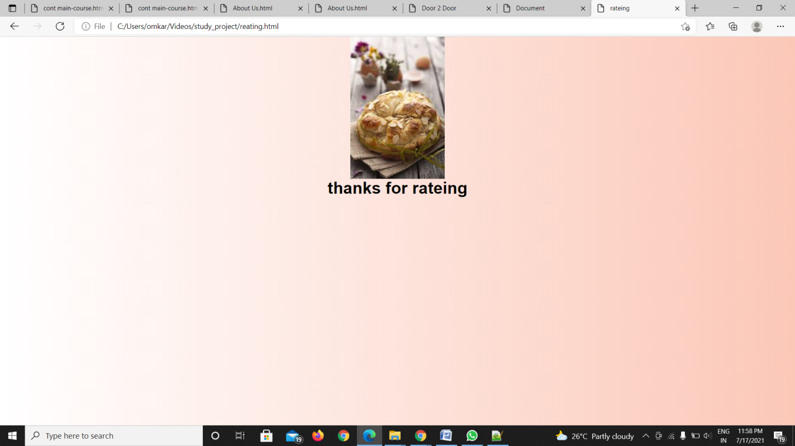

5.CHEAF

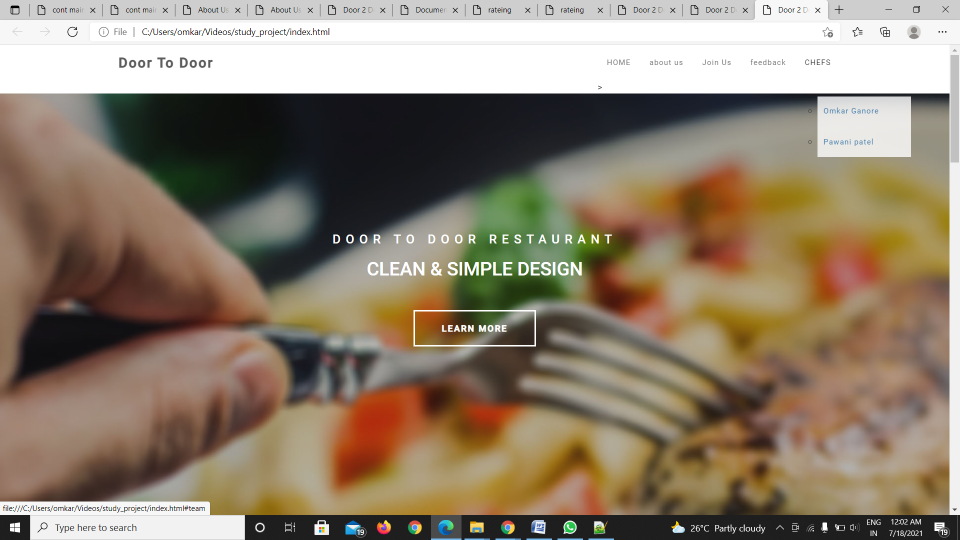

**6.PAYMENT PAGE:**

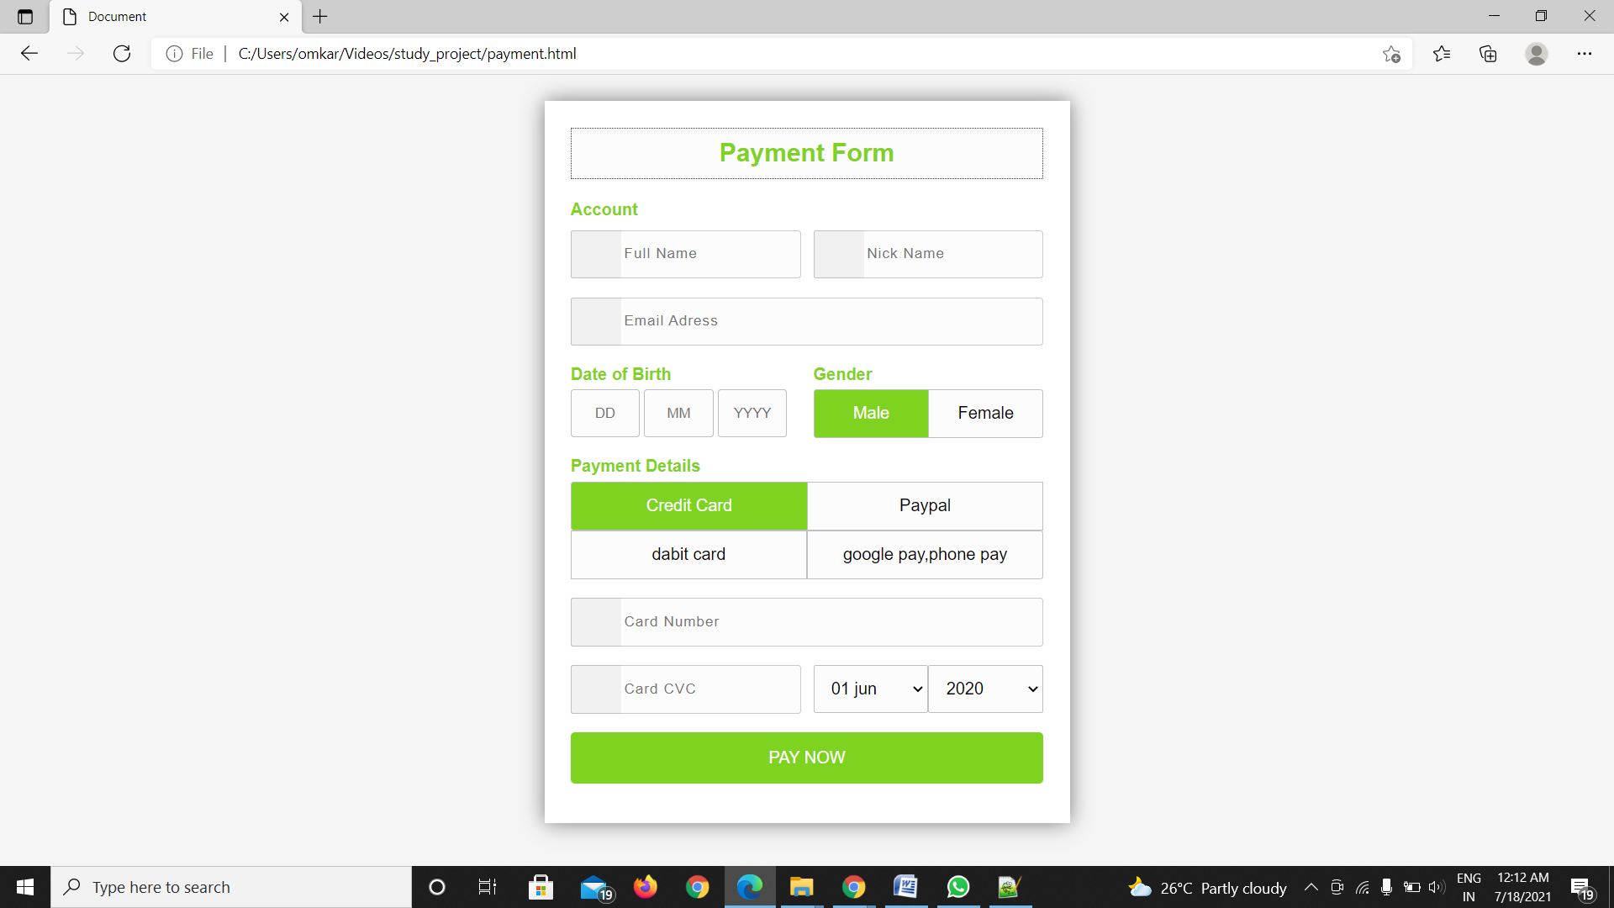

**<!DOCTYPE html>**

**<html lang="en">**

**<head>**

**<meta charset="UTF-8">**

**<meta name="viewport" content="width=device-width, initial-scale=1.0">**

**<title>Document</title>**

**<link href="r.css" rel="stylesheet">**

**</head>**

**<body>**

**<div class="wrapper">**

**<h2>**

**Payment Form</h2>**

**<form method="POST">**

**<h4>**

**Account</h4>**

**<div class="input-group">**

**<div class="input-box">**

**<input type="text" placeholder="Full Name" required class="name">**

**<i class="fa fa-user icon"></i>**

**</div>**

**<div class="input-box">**

**<input type="text" placeholder="Nick Name" required class="name">**

**<i class="fa fa-user icon"></i>**

**</div>**

**</div>**

**<div class="input-group">**

**<div class="input-box">**

**<input type="email" placeholder="Email Adress" required class="name">**

**<i class="fa fa-envelope icon"></i>**

**</div>**

**</div>**

**<div class="input-group">**

**<div class="input-box">**

**<h4>**

**Date of Birth</h4>**

**<input type="text" placeholder="DD" class="dob">**

**<input type="text" placeholder="MM" class="dob">**

**<input type="text" placeholder="YYYY" class="dob">**

**</div>**

**<div class="input-box">**

**<h4>**

**Gender</h4>**

**<input type="radio" id="b1" name="gendar" checked class="radio">**

**<label for="b1">Male</label>**

**<input type="radio" id="b2" name="gendar" class="radio">**

**<label for="b2">Female</label>**

**</div>**

**</div>**

**<div class="input-group">**

**<div class="input-box">**

**<h4>**

**Payment Details</h4>**

**<input type="radio" name="pay" id="bc1" checked class="radio">**

**<label for="bc1"><span><i class="fa fa-cc-visa"></i> Credit Card</span></label>**

**<input type="radio" name="pay" id="bc2" class="radio">**

**<label for="bc2"><span><i class="fa fa-cc-paypal"></i>Paypal</span></label>**

**<input type="radio" name="pay" id="bc3" class="radio">**

**<label for="bc3"><span><i class="fa fa-cc-rupay"></i>dabit card</span></label>**

**<input type="radio" name="pay" id="bc4" class="radio">**

**<label for="bc4"><span><i class="fa fa-cc-rupay"></i> google pay,phone pay</span></label>**

**</div>**

**</div>**

**<div class="input-group">**

**<div class="input-box">**

**<input type="tel" placeholder="Card Number" required class="name">**

**<i class="fa fa-credit-card icon"></i>**

**</div>**

**</div>**

**<div class="input-group">**

**<div class="input-box">**

**<input type="tel" placeholder="Card CVC" required class="name">**

**<i class="fa fa-user icon"></i>**

**</div>**

**<div class="input-box">**

**<select>**

**<option>01 jun</option>**

**<option>02 jun</option>**

**<option>03 jun</option>**

**</select>**

**<select>**

**<option>2020</option>**

**<option>2021</option>**

**<option>2022</option>**

**</select>**

**</div>**

**</div>**

**<div class="input-group">**

**<div class="input-box">**

**<button type="submit">PAY NOW</button>**

**</div>**

**</div>**

**</form>**

**</div>**

**</body>**

**</html>**

**Order place:**

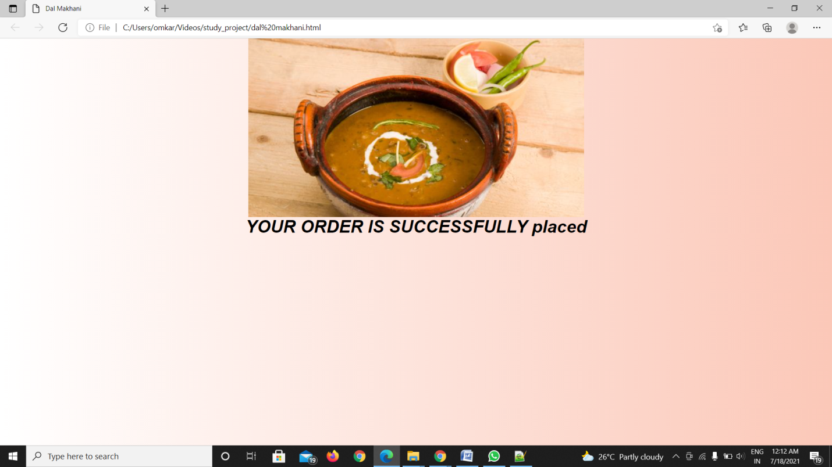

**<html>**

**<head>**

**<title>Mushroom Risotto</title>**

**<link href="style.css"rel="stylesheet"type="text/css">**

**<body background=".JPG">**

**<center>**

**<imgsrc="mashroom riscotta.JPG"/>**

**<h1><b><i>YOUR ORDER IS SUCCESSFULLY ORDER</h1></b></i><br><br>**

**</body>**

**</html>**

**DATABASE:**

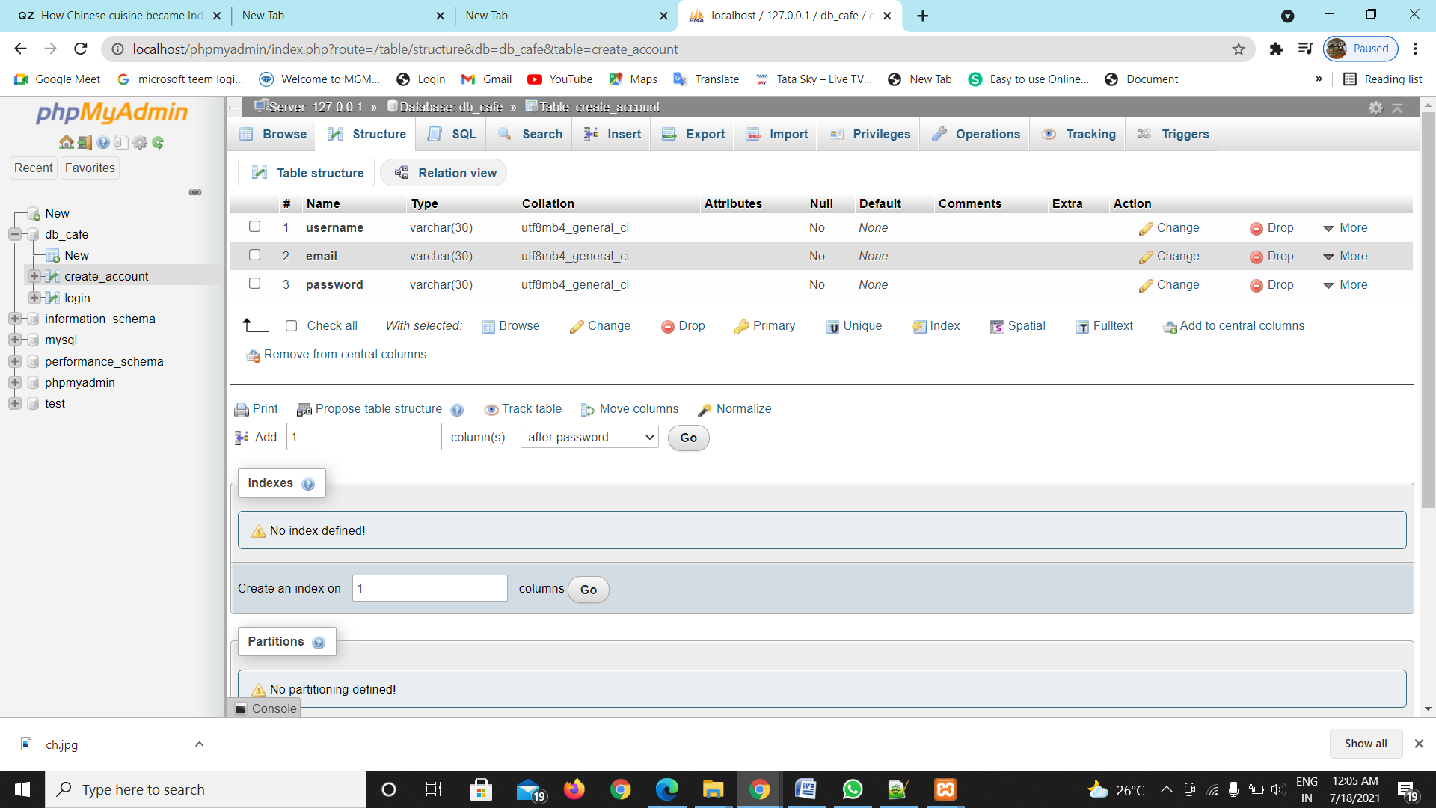

**<?php**

**// database connection code**

**// $con = mysqli_connect('localhost', 'database_user', 'database_password','database');**

**$con = mysqli_connect('localhost','root','','db_cafe');**

**if($con)**

**{**

**echo "connected";**

**}**

**else**

**{**

**echo "not co";**

**}**

**// get the post records**

**$txtName = $_POST['username'];**

**echo $txtName;**

**$txtEmail = $_POST['email'];**

**echo $txtEmail;**

**$txtPass = $_POST['password'];**

**echo $txtPass;**

**// database insert SQL code**

**$sql = "INSERT INTO `create_account`(`username`, `email`, `password`) VALUES ('$txtName','$txtEmail','$txtPass')";**

**echo "query run";**

**// insert in database**

**$rs = mysqli_query($con, $sql);**

**if($rs)**

**{**

**echo "Records Inserted";**

**header('location:login.htm');**

**}**

**?>**

**LOGIN PAGE DATABASE**

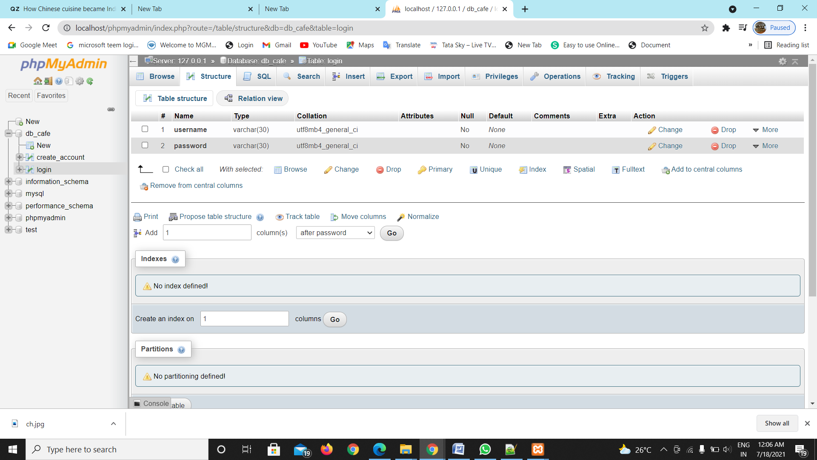

**<?php**

**$con = mysqli_connect('localhost','root','','db_cafe');**

**if($con)**

**{**

**echo "connected";**

**}**

**else**

**{**

**echo "not co";**

**}**

**// get the post records**

**$txtName = $_POST['email'];**

**echo $txtName;**

**$txtPass = $_POST['password'];**

**echo $txtPass;**

**// database insert SQL code**

**$sql="select*from create_account where username='$txtName' && password='$txtPass'";**

**$result = mysqli_query($con,$sql);**

**$num = mysqli_num_rows($result);**

**if($num == 1)**

**{**

**header('location:index.html');**

**}**

**else**

**{**

**echo "invaild credentials";**

**}**

**?>**

CONCUSION:

1. ​​​​​​​ It is a fact, if your customers like your service, they will come back and also recommend you to their world. They will become your best advertisers. So, you need to commit to a service that keeps them coming back.

1. It can be done by making the ordering process convenient for them. Eventually, this “convenience” will pay huge dividends for your restaurant. One thing is certain that people don’t like to order their food over the phone. Everyone wants to place their order without fuss and undoubtedly, asap.

1. People don’t want to spend 5-6 minutes as they place their order over the phone by looking at the ordering catalogue and pausing whatever work they were doing.